We were blessed to have found Karen when we were looking for a trainer for our rottweiler puppy, Buster. Buster was a very active, very intelligent little boy who needed guidance from us, his owners, in order to become the wonderful, fun-loving companion that he became. With Karen’s expertise and understanding of dogs, specifically rottweilers, Buster became a valued and much loved member of our family and neighborhood. We went through several classes with Karen, including the beginning, intermediate and advanced classes. We were able to not only teach Buster basic obedience commands but more advanced commands as well. Through Karen’s urging, we put Buster into a Canine Good Citizen class and he passed the CGC test with flying colors! When the classes were finished we were able to utilize everything we had learned in the classes in order to continue the training throughout Buster’s life.

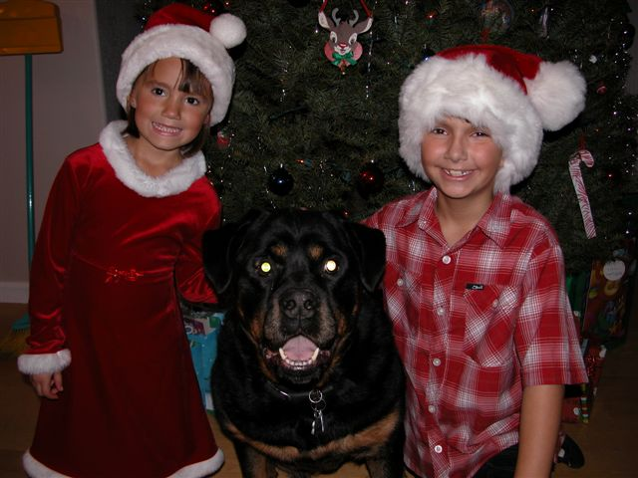
Unfortunately, Buster passed away at a very young age and we weren’t able to enjoy him for all the years we had hoped. But when it came time to find another pet, knowing that Karen was a breeder, we turned to her for guidance in finding another rottweiler that would fit into our family. By sheer luck, just at that time one of Karen’s dogs had just sired a litter and we were able to pick from that litter. Karen insisted, and we willingly complied to take this puppy to training classes when he was old enough. Until that time we were able to start the training process because we knew, from Karen’s classes, just what to do. Max is now over ten years old and Karen is still very much a part of our lives as well as his. Because of the training that we started with Max when he was so young, he has continued to grow and amaze us with his abilities to understand and comply with any request we have of him. If it weren’t for the expertise and care that Karen has shown from the moment we met her, we may not have been able to get the full enjoyment from Max that we do. We have taught our two young children the proper commands and Max listens to them just as well as he listens to us!

Just recently we turned to Karen again when we ready to get another puppy to add to our family. She didn’t have any pups available at the time we were ready for one, so she went out of her way and took many hours of her time to find us just the right breeder with just the right puppy for our family. Jazmine joined us just a few short weeks ago and we have already started to implement the training that Karen had taught us all those years ago. And when I need a little extra help, Karen is always right there with a helpful answer. In fact, because Karen no longer lives in our area, she has found us a trainer that she worked with years ago so that we can start Jazmine in classes just as soon as she is old enough.
So I would like to say many, many thanks to Karen for everything she has done for us and our ever growing family!!

Steve & Elissa Heredia and Family

